Exploring MySQL with Codio II

By Stephen Johnson

The following are three screenshots (A, B, C, D, E, F, G) which a connection database, creation of an employee table, creation of a branches table, and insertion of record into the employee table with and without support are displayed with the query language, SQL, using Codio as an environment.

(A)

After viewing last week’s database information, I created an employee table with information given: CREATE TABLE Employee (

Employee_ID SMALLINT,

First_Name VARCHAR(40),

Last_Name VARCHAR(60),

Department_ID SMALLINT,

Classification VARCHAR(10),

STATUS VARCHAR(10),

Salary DECIMAL(7,2));

(B)

A table of Branches were created as well as seen above.

(C)

The employees table with inserted records is displayed here with the support of given information.

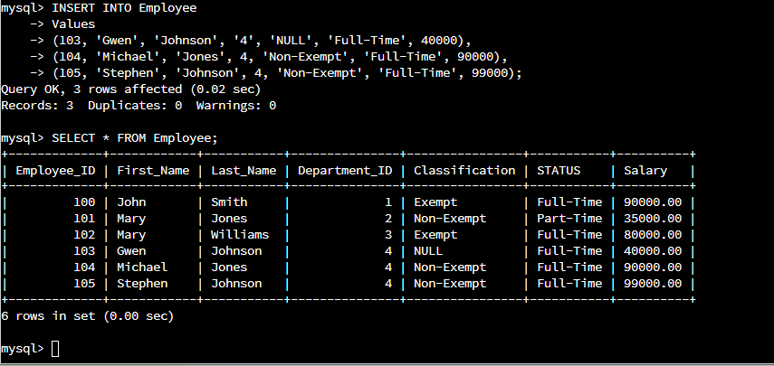(E)

Information was added to the employee table without supportive data; however, the input was successful. My name was added to the employee table with fictional additions, such as, the marketing Department affiliation, non-exempt classification, full-time status, and a maximum salary of $99,000.

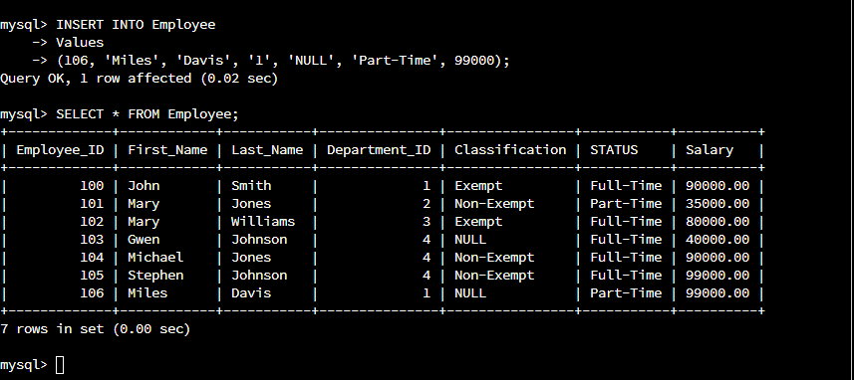(F)

The legendary jazz musician, Miles Davis, was added to the employee table. NULL was added as classification, part-time status, accounting department affiliation, with the maximum salary of $99,000.

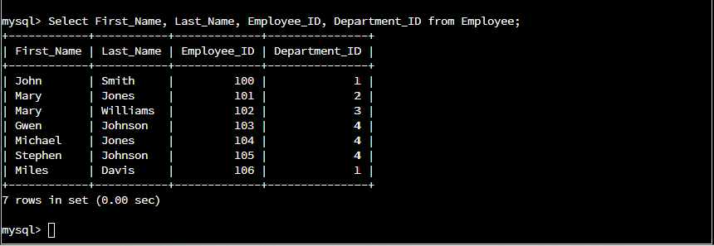(G)

This is the result and conclusion of the displays with the FIRST NAME, LAST NAME, EMPLOYEE ID, and DEPARTMENT ID from the given employees.